**Name: Zenroy Chance**

**Student No. : 410921338**

**Course : Introduction to VR**

**Project No. : 5**

**Project Title: SniperSIMS**

**Due Date: 3/1/23**

**Introduction**

***Problem Statement***

In most military organizations when artillery field training is done resources are burnt and in turn finances. Snipers are one of the most expensive firearms and in field training these firearms may get damaged and ammunition is also depleted.

***Definition of scope and approach***

Using VR a field training sniper simulation will be developed. Normally field training is done within one location unless Soldiers are sent on tour. This simulation would allow for snipers to do aim training simulation within different environments. Trainees(Users) would be able to move around an open world environment of their choosing and shoot a sniper rifle at a number of targets.

**Background**

***State of the art review***

Virtual reality simulations that can recreate and augment combat training to aid in the development of visual and cognitive abilities. The improved abilities may, in turn, instil confidence before the presence of active combat action. This article reviews emerging approaches, technologies, and trends in military cognitive training. Review of supporting research is provided.

**Method**

***Implementation***

SniperSIM (SSM) application is built using Unity and C# as the programming script. Procedures that determined from the design phase are coded and documented.

***How it works?***

1. User enters an environment and is able to change location using the keys on the keyboard (W, A, S, D)
2. The mouse is then used to scope into an enemy using the right mouse button. Note: a player cannot take a shot unless they are scoped in.
3. After scope is enabled, the player will use their mouse to locate a target. Users can adjust the scope using the mouse wheel button; zoom in or out.
4. To shoot the user will press the left mouse button.
5. Steps 1-4 is repeated until all enemies are killed.

**Technical Specifications**

***Tools***

* Unity
* Blender (Concept)

***API / Baseline assets***

* Ammunition Pack
* RPG_FPS_game_assests
* SniperRifle
* ToonSoldiers_WW2
* Animations
* Materials
* Scenes
* Scifi Guns SFX Pack
* Textures

**Preliminary Results**

**Results**

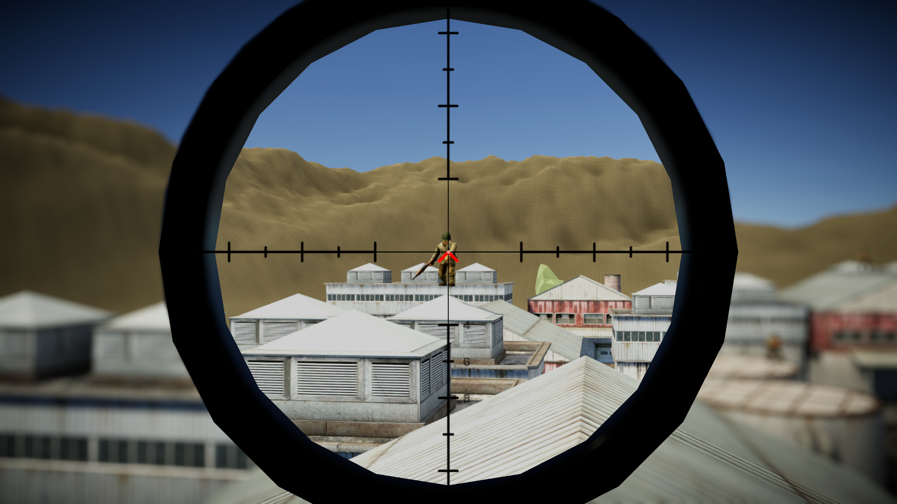

*Image1: Scoped shot from rooftop (Pre-death)*

*Image 2: Scoped shot from rooftop (Death)*

*Image 3: Full Scoped shot*

***Code: Below is a few code implementations from the project***

*Script: PlayerShootingController – these are 2 key functions within SniperSIMs handle scope changes the player Field of View to be scoped in or out of the rifle. It incorporates external functions to that aid in these changes. See Image 2.*

*Image 2: External functions that aid in the scope change in image 1. View scope.cs for full implementation*

**Discussion**

SniperSIM is a game developed to simulate sniper field training through CVVR. The game was developed using the Unity engine alongside C# scripting for functionality implementation. Firstly, the mountains around the compound were created using the extrude brush in unity. Then using the assets imported from RPG_FPS_game_assests, the compound was built. The created compound was inspired by buildings that can be found in middle eastern countries like Afghanistan and Syria to name a few. The green enemies were created using the ToonsSoldiers_WW2 assets pack. Animations were then attached to these soldiers. This brought a bit of life to the game. Ragdoll physics were also applied to the enemies so when shot it would look a bit realistic. The project included a bit of sound effects when the rifle was shot to mimic real life rifle sounds. This was implemented using a 3rd party asset pack called Scifi Guns SFX Pack. For the Player character. Scripts were written to allow for movement, scope animations and shot accuracy. Trees, cars, planes and other objects around the map was implemented using the polygon starter package.

Limitations faced during the development was the ability to implement the use of VR with the software. So, this feature would roll out in later development. Another limitation faced during development is the capacity of my PC (computer) to handle the development, making the process slow.

**Conclusion**

In this project the Minimum Viable Product includes features such as an environment, movement, Humanoid targets, animations, user controls. No VR was implemented in the pilot of this project; however, the project scope was still delivered.